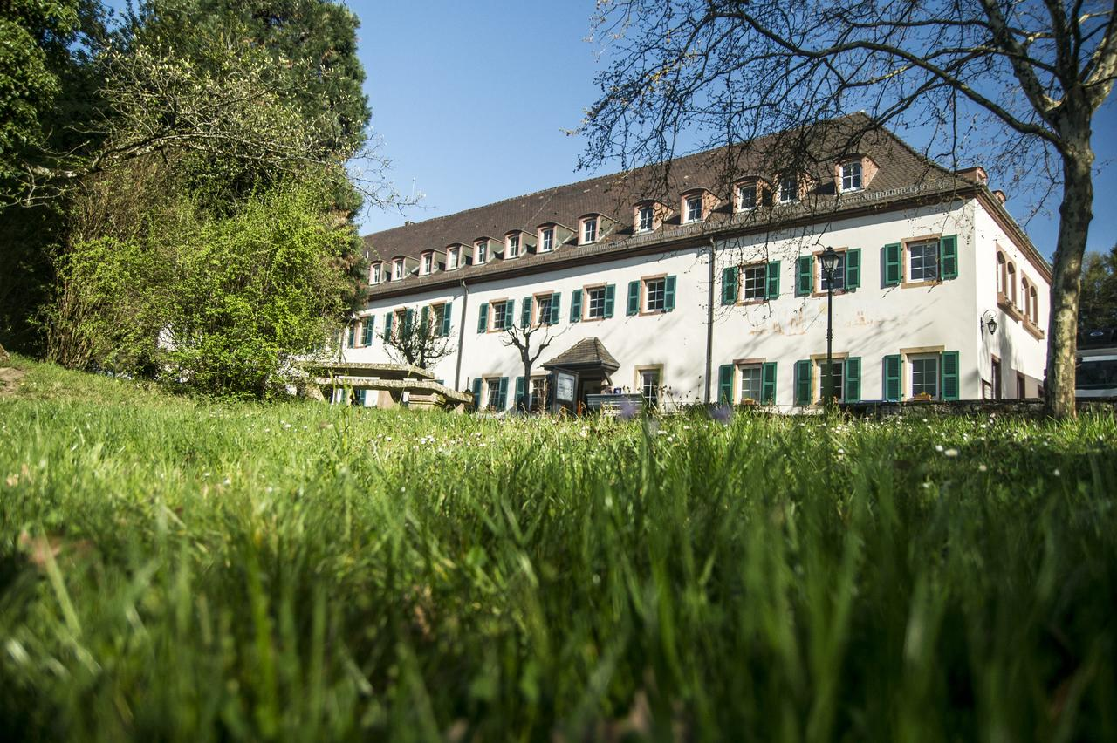
LIEBFRAUENBERG
Friday 13 – Sunday 15 March 2020
Theme “Exile” led by
The Very Reverend Michael Sadgrove
Dean Emeritus of Durham

This year we again mark Lent and the approach of Spring by coming together from our three chaplaincies and gathering in our beloved Liebfrauenberg. As always we shall think about our Christian beliefs and faith, prepare for Easter, walk in the woods, talk with friends of many years and welcome new friends.

Our leader and theme
This year we are happy to welcome the Sadgroves, Michael and Jenny, to be with us. We look forward to some enriching Bible studies on the theme of “Exile”. Michael hopes these may relate to our experiences today following Brexit, as some of us are being called to leave our “comfort zone” as Europeans and seek out lots of pieces of paper which will enable us to continue to live in the countries which we have called “home” for decades.

Jenny and Michael live near Hexham in Northumberland, having “retired” there from Durham. Jenny is a psychotherapist who is continuing to work in private practice in Tynedale, while Michael has been active as a speaker and preacher, retreat conductor and writer, not least on European themes.

This Liebfrauenberg weekend will mark the beginning for them of a new phase of retirement in which the enjoyment of family, friendship and personal life take precedence as they make the most of the opportunities the “third age” offers. We are very grateful to them for including our weekend as one of Michael’s last commitments in public ministry.

The studies will focus on four passages from the Hebrew Bible (the Old Testament). These are: the patriarch who leaves home for a far country (Abraham, Genesis 12); the stranger who is welcomed into an alien community (Ruth); the psalmist who wonders how to sing the Lord’s song in a strange land (Psalm 137); and the prophet who exhorts his people to make their home in exile (Jeremiah 29). We shall finish with one from the New Testament: Jesus’ parable of the prodigal son whose story demonstrates exile and restoration in lived experience. (Please bring a Bible.)

In his blog http://northernwoolgatherer.blogspot.com (which is well worth reading) Michael Sadgrove describes himself as a “pilgrim, priest and ponderer”. A Londoner of Anglo-German parentage and a fervent European by conviction, he has been over forty-five years of ordained ministry a parish priest, theological educator, cathedral precentor and a Dean at two cathedrals, Sheffield, then Durham.

Practicalities and Costs

As always costs are kept as low as possible This year the cost for adults is 80 euros per person per night, with all meals included. Young people 13-17 years: 58 euros per night. Children 4-12 years: 45 euros per night Children under 4: no charge. (If there are at least four children there will be a special programme for them.) If you need any help please speak to John or Diane Murray.

The programme begins with supper on Friday evening at 19h 00.
It would be very helpful if you could let Diane or John Murray know by 1 March if you are planning to come by emailing us at john.murray67@googlemail.com or by returning this form.

REGISTRATION FORM

FULL NAME(S)
…………………………………………………………………...

….................................................................................

ADDRESS ………………………………………………………

…................................................................................

…………………………………………………………………….

TELEPHONE …………………………………………………….

EMAIL ……………………………………………………………

ACCOMMODATION REQUIRED:

Single Double Family

SPECIAL DIET OR NEEDS

…………………………………………………………………….

TIME OF ARRIVAL
Friday 7 p.m. (i.e. in time for evening meal)
Friday 8 p.m or later
Saturday 12.00 (in time for lunch)

