The Bishop in Europe:
The Right Reverend Dr. Robert Innes

2021 Bishop’s Lent Appeal for the English Church of Liège (Belgium)

My Lent Appeal this year is concerned with restarting ordained ministry in a chaplaincy that has gone through tough times but where there is great potential. The new chaplain is one of the (very few) stipendiary, trained curates from our own diocese. The Reverend Guy Diakese trained for the priesthood in Nigeria and Rome. He speaks French, English and Italian fluently and we are very proud of him as an example of black minority ethnic leadership in the Diocese. The money raised through this appeal will enable the beginning of Guy’s ministry in Liège, a former industrial city which is now home to large numbers of migrants from beyond Europe.

Background
The life of an English-speaking Christian community in Liège dates back to 1654, when Prince Charles of Great Britain visited the curative waters in nearby Spa, with subsequent generations of Britons following his example. From the 1960s, Spa attracted fewer visitors, though, so the church moved to the provincial capital city of Liège. This was only fully formalized in 2015, when official legal recognition transferred from Spa to Liège. However, since then, the Chaplaincy has gone through challenging times…
In 2016, the Chaplain, the Revd Paul Yiend, was diagnosed with cancer, and sadly passed away in September 2019. His long and devoted ministry, great service and deep friendship have been dearly missed in Liège. The efforts of a local Ministry Team, and in particular the efforts of Pastoral Support Worker, Ruth Nivelle, enabled the small congregation to keep worship services and community activities going during a period of insecurity and grief.
COVID-19 placed additional burdens, with which we have all grown familiar, on a struggling Chaplaincy.
The Belgian Deanery’s hardship fund helped Liège cover its Diocesan quota this year, and the Holy Trinity Brussels’ Mission Committee provided a grant for operational costs at the end of 2020. Without these generous gifts, the Chaplaincy might not have survived.

A Fresh Start
The lockdown has not helped with outreach and growth, but committed members and the local leadership team persevere in the faith, and despite decreased income, there are new signs of hope.
Over the past year while transitioning to online worship and Zoom Bible Studies, the Council carefully prepared for a new Chaplain, and a gifted and suitable candidate was soon found!
The Revd Guy Diakiese Matumona, who served his curacy at St John and St Philip’s in the Hague, is planned to be the new Chaplain in Liège, beginning in March 2021. And Ruth Nivelle has completed her Lay Reader training and will soon be licensed.
Chaplaincies in Belgium receive some support towards clergy stipends via the ‘traitements’ provision, which makes Guy’s ministry there tenable. And the Church of England will cover Guy’s pension contributions thanks to his status as an ICS Mission partner. But the English Church in Liège cannot yet afford to provide accommodation for Guy, among other things.
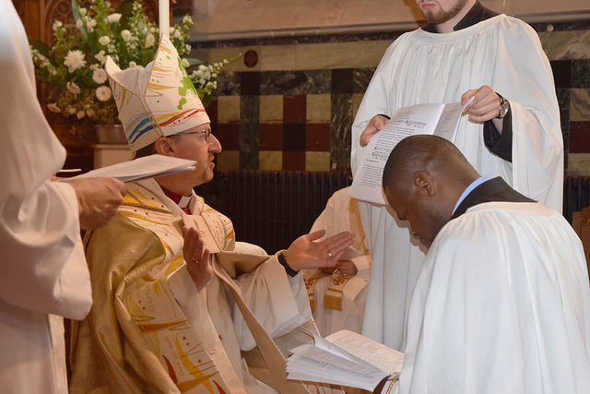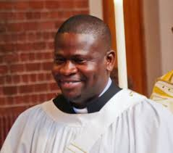

The Chaplaincy Context and Mission
There is a great need, but also great potential, for a English-speaking ministry in Liège.
Liège is a city of about 200,000 people, the fourth biggest in Belgium. About 20% of these are of foreign nationality; plus many other second-generation immigrants and other Belgian citizens with foreign roots. Although the largest group of foreign nationalities in Liège comes from French-speaking countries (e.g. Morocco or DRC), a large number will also use English as their second or even first language, most notably those from Ghana, Cameroon, Nigeria and Uganda. In addition, there are about 25,000 students, 24% of which are international, from 128 different nationalities.
Even in hard times, the Chaplaincy leadership has proven resilient and dedicated, and looks forward to working with its new Chaplain to generate growth, both spiritual and numerical.

The Council has identified three commitments they desire to be true to in the coming time:

Committed to growing disciples of Jesus Christ -
through worship services, Bible Studies, Sunday School and fellowship

Committed to care -
through a soup kitchen, support of the Protestant Social Centre and by being environmentally responsible.

Committed to Ecumenism
Working with other Christian communities has been important through this chaplaincy’s history and remains so today.

You can find out more about the Liège chaplaincy with these links
Website: www.englishchurch-Liège.be
Facebook Page: https://www.facebook.com/englishchurchLiègeanglican
YouTube Channel: https://www.youtube.com/channel/UCQoEqT5G14fpGqXaqzxVHUA
Email: secretary@englishchurch-Liège.be

I am very much aware of the financial demands placed on all our chaplaincies by the Covid crisis. I nonetheless commend my Lent appeal to you warmly, hoping that we can all share in the hope that this new start for the chaplaincy of Liège promises.

I wish you a holy and spiritually fulfilling Lent in these difficult times.

With every blessing,

+Robert Gibraltar in Europe

